

Games

Project Report

DT228/DT282

Web Development 1

**Ayan Abedin**

School of Computer Science

Technological University Dublin

**19/12/2020**

Declaration

I hereby declare that the work described in this dissertation is, except where otherwise stated, entirely my own work and has not been submitted as an exercise for a degree at this or any other university.

Signed:

Ayan Abedin

Ayan Abedin

19/12/2020

Table of Contents

*1.* Problem Description 4

*2.* Research 4

*3.* Technology Selection and Site Architecture 4

*4.* Low Fidelity Prototype 5

*5.* Development Plan 12

*6.* Testing Plan 13

*7.* Site Evaluation 16

*8.* Deployment 17

*9.* weekly logs 17

*Program Description*

This is a website built on Games. It tells the user about the best-recommended video games of 2020 as recommended by IGN. IGN (Imagine Games Network) is an American [video game](https://en.wikipedia.org/wiki/Video_game) and [entertainment media](https://en.wikipedia.org/wiki/Mass_media) [website](https://en.wikipedia.org/wiki/Website) operated by IGN Entertainment Inc.; focuses on [games](https://en.wikipedia.org/wiki/Game), [films](https://en.wikipedia.org/wiki/Film), [television](https://en.wikipedia.org/wiki/Television), [comics](https://en.wikipedia.org/wiki/Comics), [technology](https://en.wikipedia.org/wiki/Technology), and other media. Four of the best video games are mentioned herein on four different pages. Each page explains the game at its best followed by images, the latest news, and videos. Many websites on the Internet provide the same information as this one would provide but one advantage is that this website will provide you the best game that is liked by all with no negative reviews.

*Research*

Before creating this website, I have looked at four different websites to gather some ideas and designs. Those are EAGames.com, CyberPunk.net, Ubisoft.com, and Origin Games. Those sites have the basic layout; big images, tile images, bold headings, minimal UI with black and white contrast, a navigation bar, some videos, and a section of the latest news. But on the other hand, the Cyberpunk site looks a bit different, it is of black and yellow contrast and the UI is a bit messy. So, I decided to create a mix of all four sites.

*Technology Selection and Site Architecture*

Here HTML 5 and CSS 3 is used. The users can view this site in any platform available- Tablet, Laptop, Phone etc. It will adapt to the viewing device as it is responsive.

*Low Fidelity Prototype*

Here are the prototype diagrams-

1. Home Page
2. Assassins Creed Page
3. Battlefield Page
4. CyberPunk 2077 Page
5. FIFA 21 Page
6. Contact Page

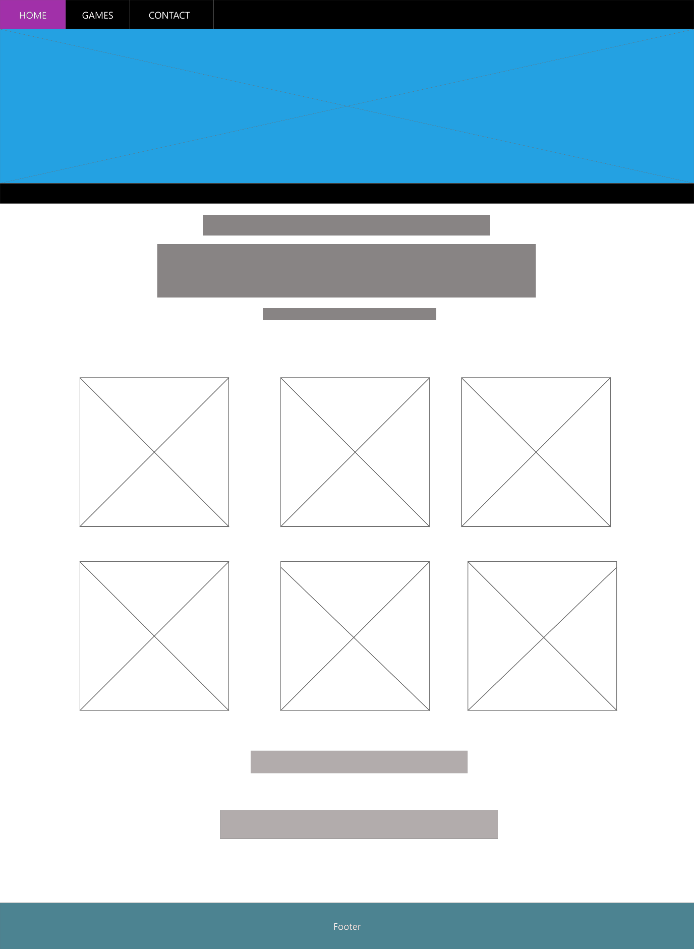

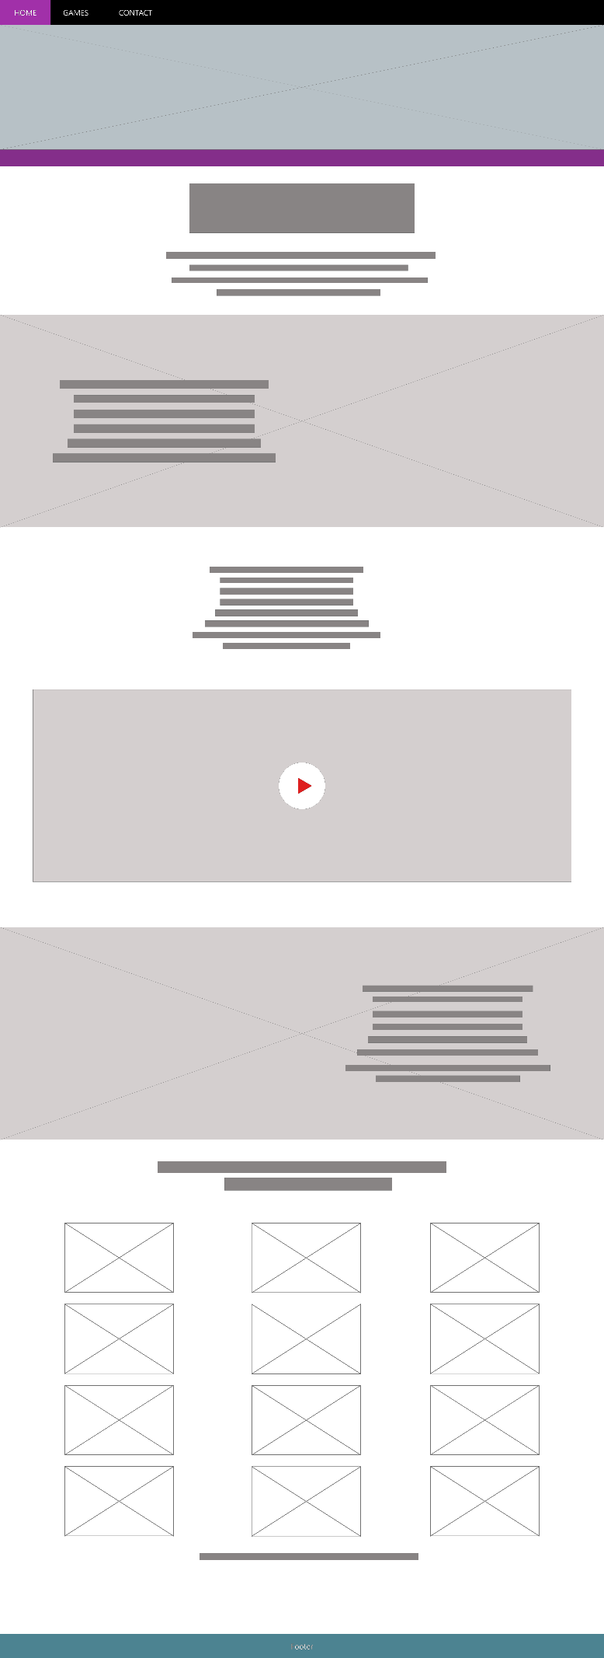

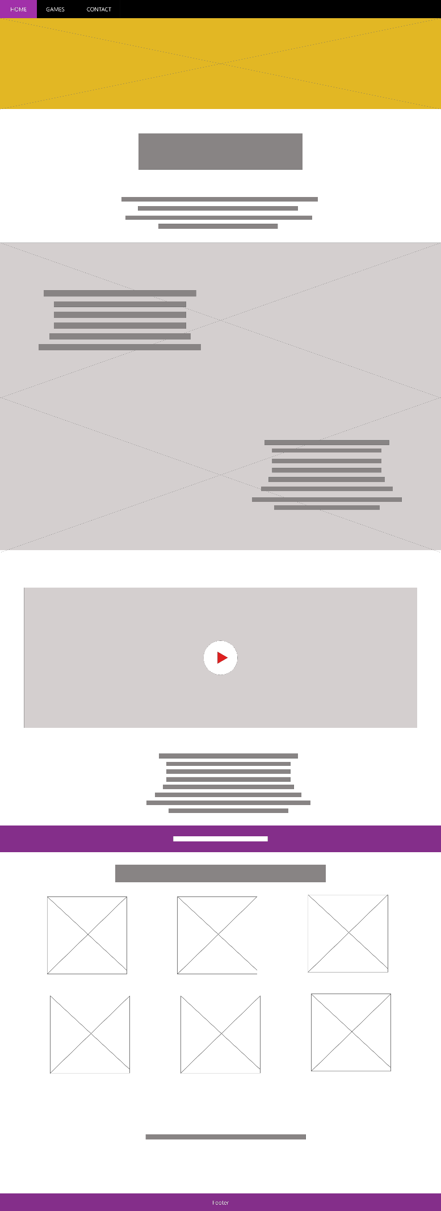

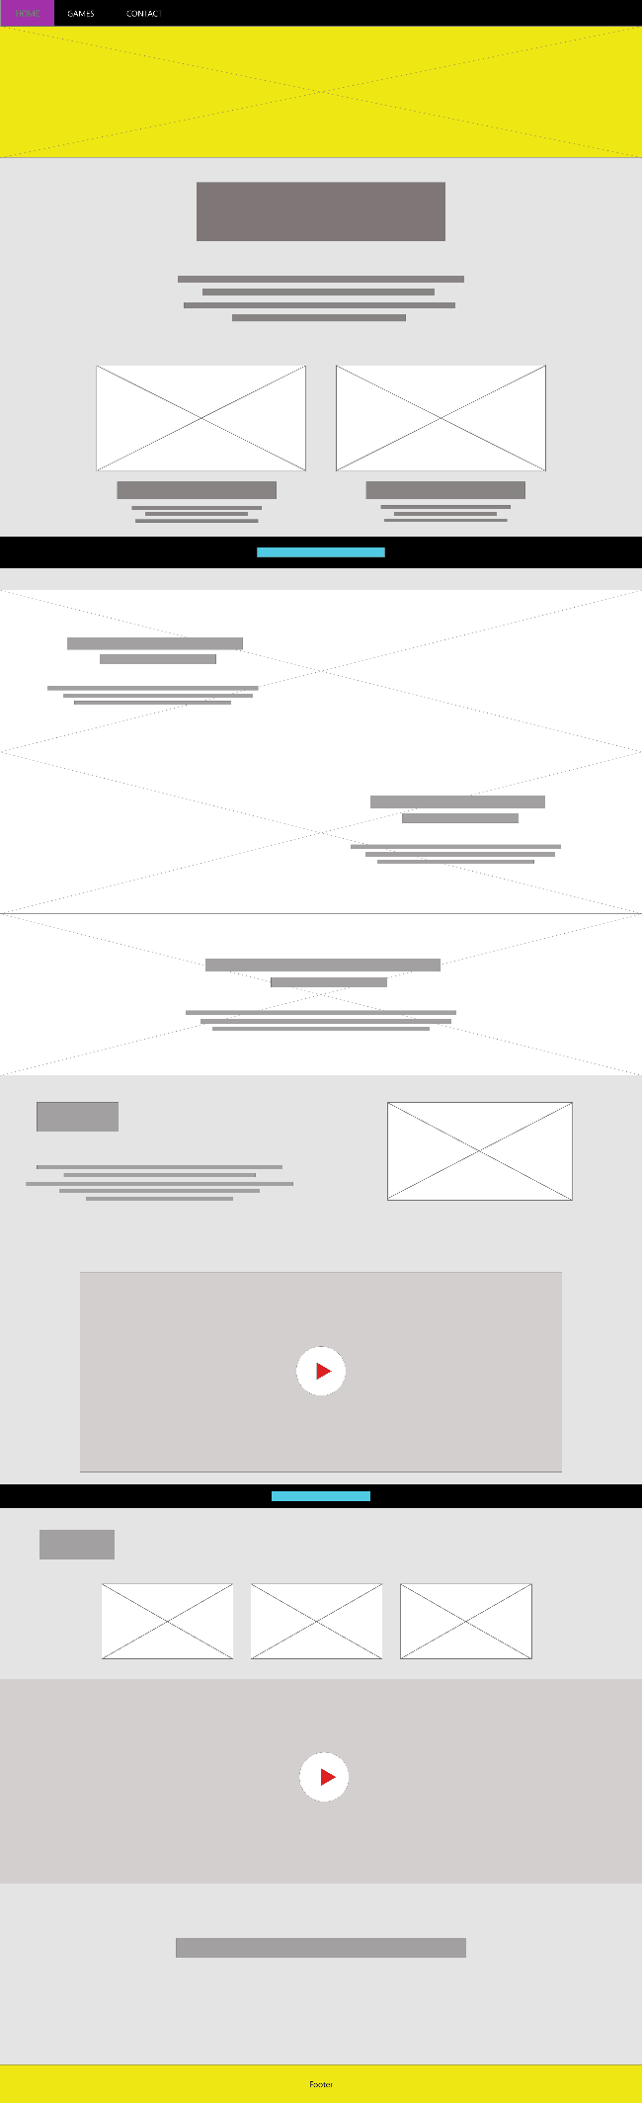

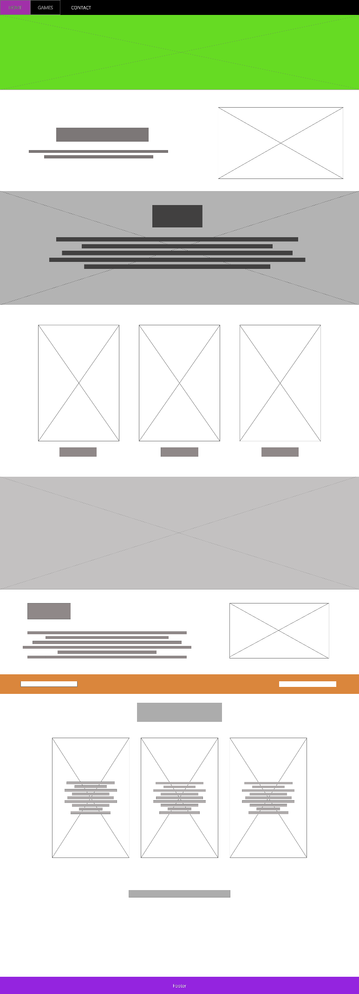

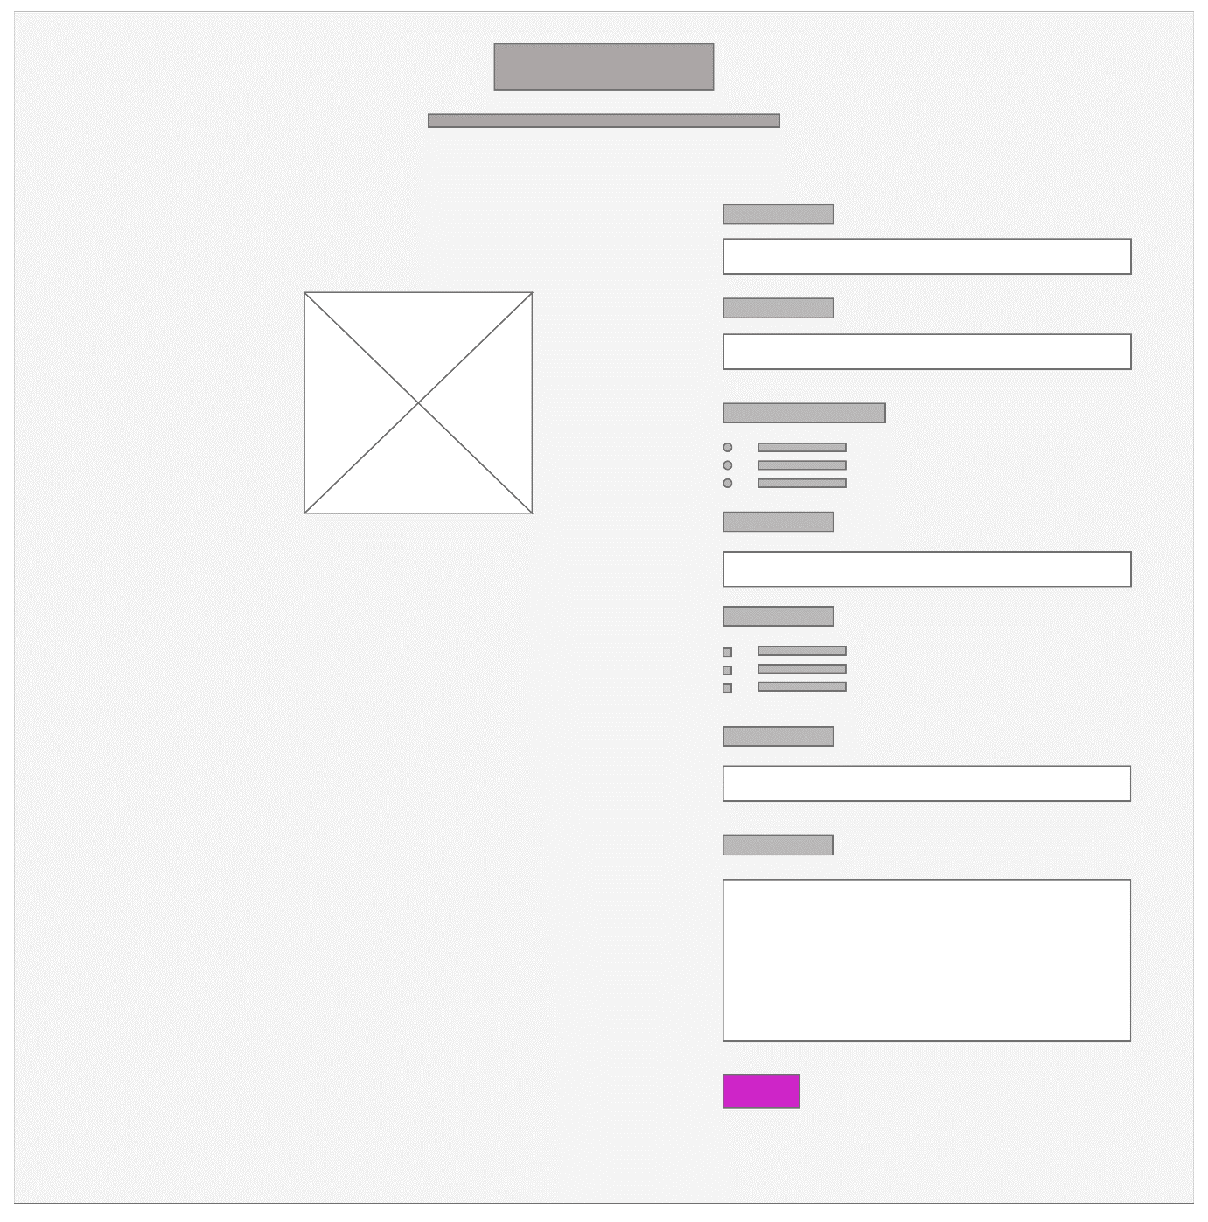

*Development Plan*

The website is created with five pages in total. The top of each page has a navigation bar (also known as menu bar) which provides an easy access to switch to different pages. It also has a drop-down menu for different pages. All the pages have a footer at the bottom displaying the creator name.

The first page is the Home Page. It has details of the best games recommended by IGN with big tile images with overlay effects. It also has links to take you to IGN.com for more details.

The second page displays the first game Assassins Creed. This page starts with a header image displaying the game name and keeps on changing every after 5 seconds. After that, the page displays a short description of the game along with some images. Then there is a YouTube video of one of the franchises of the game followed by a few more descriptions of what the game contains along with an image which is used as a Banner. Following this is a list of all the sequels of Assassins Creed ever produced in tile structure that has a link in them to take you to the Ubisoft website for more information.

The third displays the second game named Battlefield. This page also starts with a header image displaying the game name. Then it has got a gradient bar that displays a tag of being the best FPS game followed by a short description of the game. After that, there are two full-size images with text in them explaining the content of the game. Following this, there is a video showing the trailer of the latest Battlefield sequel. After this, there are a few more details on what gamers can do in the game. Following this, there is a tile of images showing all the sequels of the Battlefield Series produced to date. At last, there is a link to take to EAGames official website for more details or information.

The fourth page is of the third game and this is a very new game released on 10th November. It is called CyberPunk 2077. It is a sci-fi action game. This webpage is a bit different. It has got yellow and black in color contrast. This page starts with a header image that is mostly designed using Photoshop. After that, there is a short description of the game followed by two images, one of which has JavaScript linked that changes and fades images every after 5 seconds. Just below these images, there is a short text that tells what you can do in the game. After that, there are three big images with text in it describing what more can be done in the game. Then there is an Extras section where it tells about the developer of the game followed by its logo to the right. Following this, there is a video of the trailer of the game embedded from YouTube using iframe. After that, there is a news section displaying the latest news and a link to visit them on the original website. Just after the news, there is a second video revealing the behind the scene of the game followed by a clickable link to the CyberPunk 2077 original website.

The fifth page is of the last game and one of the most popular games from years, FIFA. The webpage starts with a header image which is edited using Photoshop followed by an image of David Beckham to the right and some text to the left. After that, there is a full-size image with text on it explaining the FIFA game. After that, three vertical images have clickable links in them to take you to the original website of FIFA. Following this, there is a short history of the origin of the FIFA Games and its popularity worldwide. Just after that, there is a gradient bar containing the slogan of the latest FIFA game, FIFA 21. Then, at last, some latest news and a link to take you to the EA Games FIFA website.

At last, the Contact Page is comprising of some embedded social links like Facebook, Twitter, Instagram, and Yahoo mail. Then there are sections for entering the first name, last name, selecting gender, entering your email, and a text box for leaving a message. The name and the email section are Java Script validated. And at last, there is the submit button.

There are five different CSS files here on this website instead of one. This is because I was facing a lot of difficulties in doing the padding and margins of different images and text inputs. Moreover, so many images and text inputs on a single CSS file looks very messy in this case.

*Testing Plan*

The site is responsive from top to bottom including text, images, menu bar, etc. But I couldn’t make the videos responsive, it stills displays at the original size when the browser is reduced to a small size. Here are some of the screenshots showing the responsive nature of the site:

**Website at full screen 100% size**

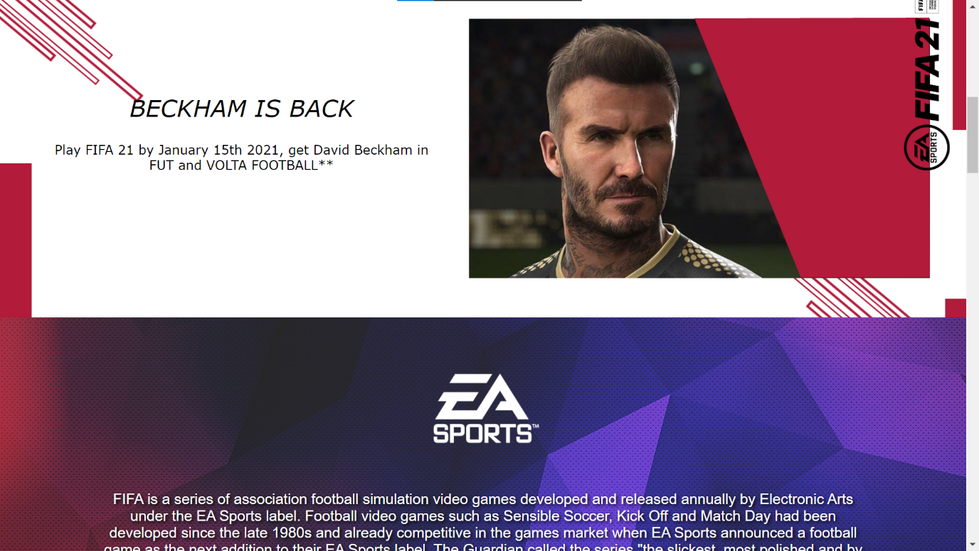

**Website at size 70%**

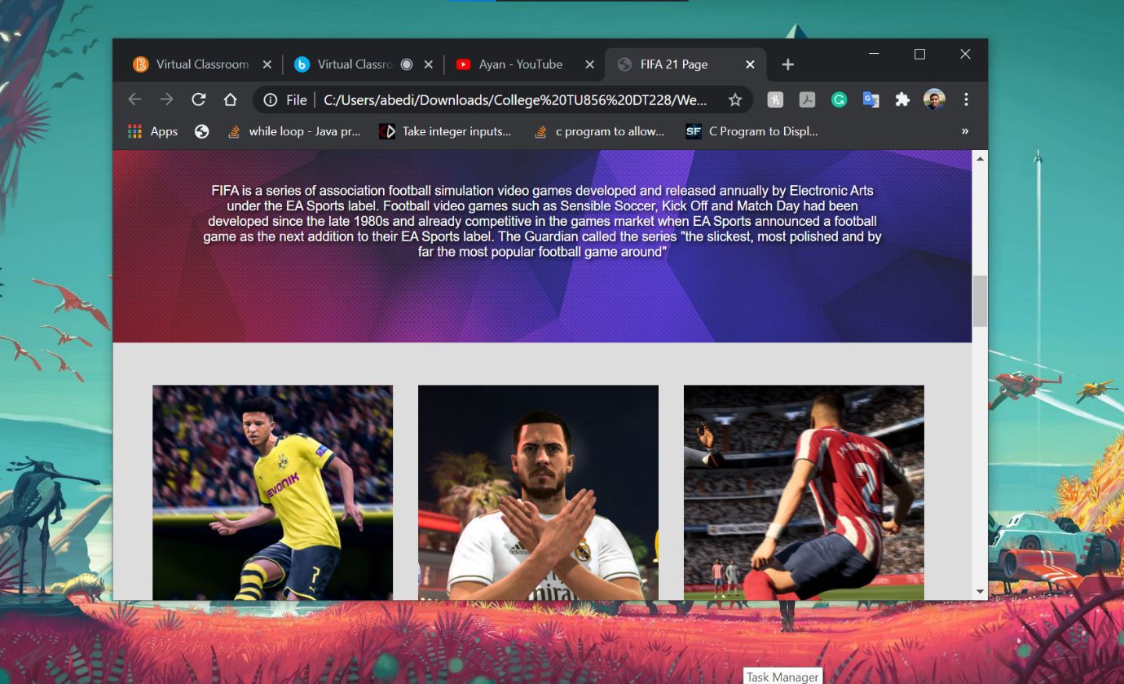

**Website at size 50%**

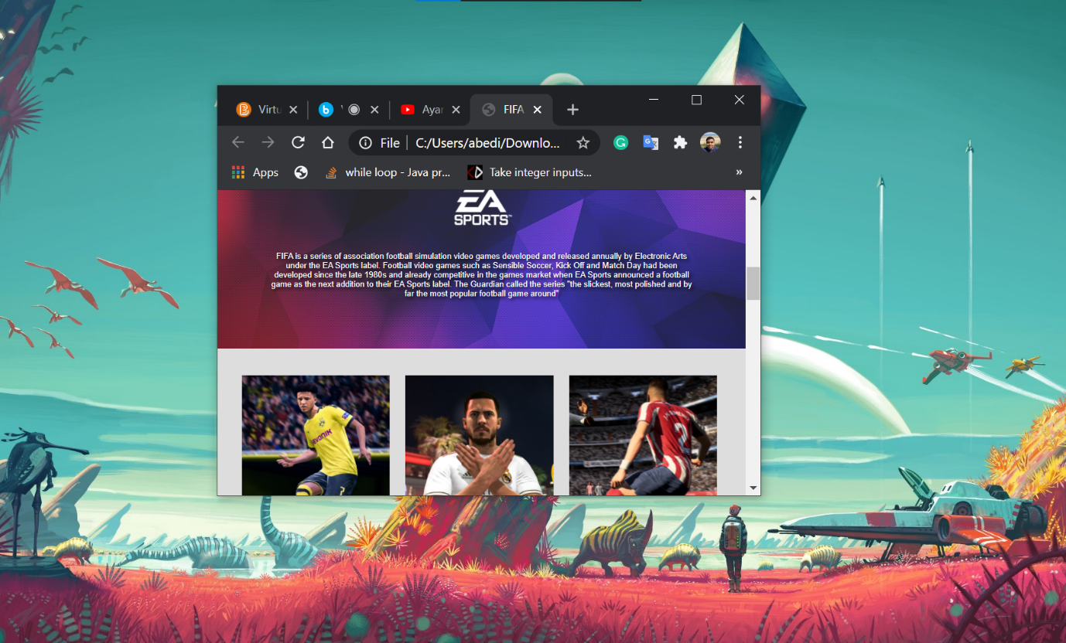

**Website at size 30%**

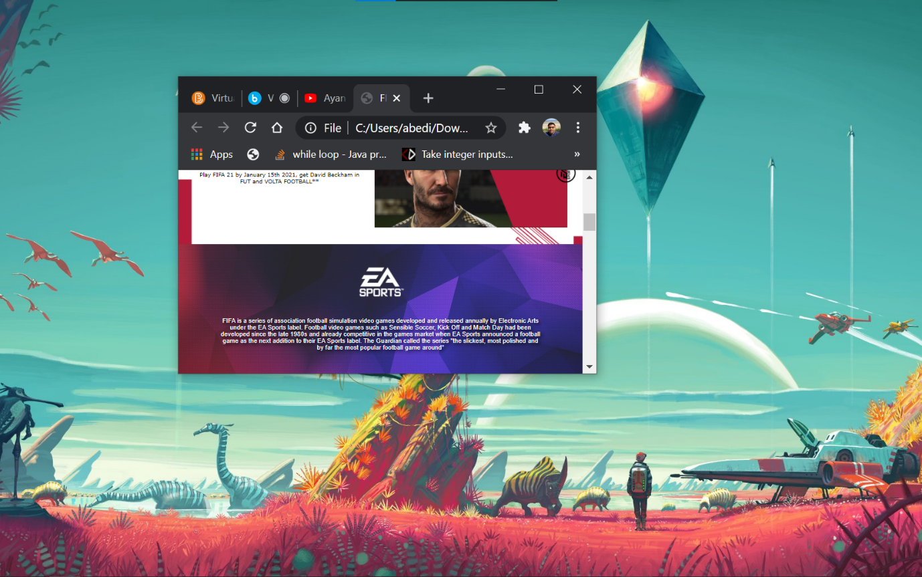

**Menu bar at size 100%**

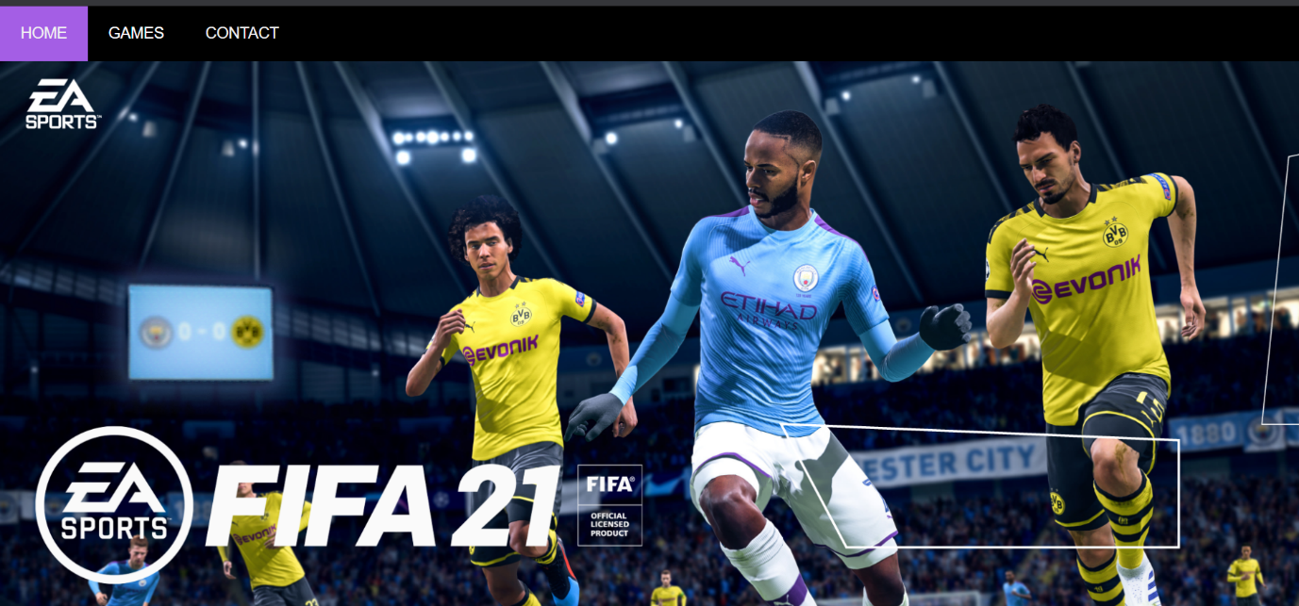

**Menu bar at size 30%**

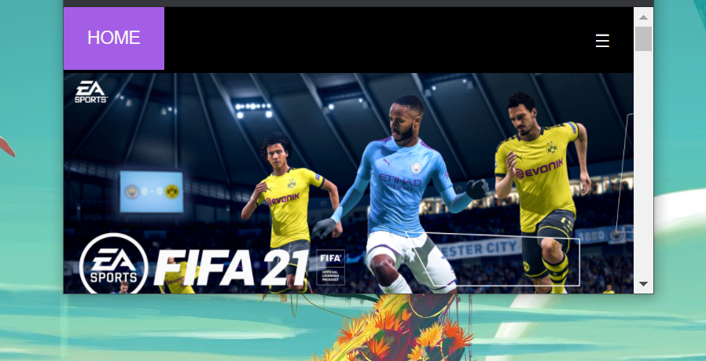

*Site Evaluation*

This website tells the user about the best-recommended video games of 2020 as recommended by IGN. IGN (Imagine Games Network) is an American [video game](https://en.wikipedia.org/wiki/Video_game) and [entertainment media](https://en.wikipedia.org/wiki/Mass_media) [website](https://en.wikipedia.org/wiki/Website) operated by IGN Entertainment Inc.; focuses on [games](https://en.wikipedia.org/wiki/Game), [films](https://en.wikipedia.org/wiki/Film), [television](https://en.wikipedia.org/wiki/Television), [comics](https://en.wikipedia.org/wiki/Comics), [technology](https://en.wikipedia.org/wiki/Technology), and other media. Four of the best video games are mentioned herein on four different pages. Each page explains the game at its best followed by images, the latest news, and videos. There are many websites on the internet that would provide the same information, but this site shows the games that have a rating of 9 or more than 9 in IGN and has a rating of more than 95% in Google. While creating this website I have used some of the codes from w3schools.com like that of making the navigation bar responsive and making the contact form validate.

*Deployment*

1.  Since it is my first website, first I used whois.domaintools.com to search for a unique domain and then register the domain name and purchased web hosting. Website hosting serves as the website’s home, allowing users from across the world to use and interact with the website.

2.  Second, I set up a DNS (Domain Name System) management administration using ZoneEdit.com. DNS translates human-readable domain names (for example, www.youtube.com) to machine-readable IP addresses (for example, 192.0.0.44).

3.  Third, I check if my site works on the liver server environment. For this, I created a sub-domain URL before officially deploying the site like dev.domainname.com as I didn’t want to make any changes in the DNS by mistake. By doing this, we can set up the website in the same physical location that it will live.

4.  Fourth, set up email accounts.

5.  Fifth, I took a full backup of the website in case things take a bad turn. And then the website goes live.

*Weekly Logs*

Log 1 (Week 7)

After days of thinking I finally decided to make a website on **Games**. I know there are a lot of gaming websites on the Internet, but this will be a different one. Since the deadline is like a month far, so I have made few checkpoints to work on this week. This is a 5-page website so I will make a basic layout of 5 different content pages and select a good background color/image for them. Then my approach is to make the first page the home page of the website. It will contain Headers, a good number of images followed by videos and some texts. I have been also thinking of putting a fixed background color/image for all 5 pages. Now moving on to the navigation bar, it will be a responsive one with drop-down menus with animations if possible. That’s all for this week and I hope I would complete these checkpoints by this week.

Log 2 (Week 8)

As discussed in the previous logbook my website will be on Games. I have completed all the checkpoints as I have discussed in the last week. So, my target for this week is to learn JavaScript and apply it to make a responsive navigation bar. I am taking help from w3schools.com for outer knowledge and using it in my project. Then I am going to complete the rest three pages of my website. I am also thinking of using some list items as well as the floating box for the images. I have also added a drop-down panel in the navigation bar for easier access. I am taking design helps from a few gaming websites such as eagames.com, Ubisoft.com, etc. So, my aim to complete it by next week at a maximum. Then I would get enough time to correct some of the faults. That’s all.

Log 3 (Week 9)

This week I am aimed to complete the project, like 90% of it needs to be completed. I am done with all the layouts of the 5 web pages. 1 or 2 of them are completely done but still, I am finding difficulty in the header section. Rest I have designed the pages as per your demands including CSS and JavaScript. My websites will contain many images, overlay effects, and many more. I am thinking of adding some videos, but the video frame is not getting a perfect fit for the borders, so I am working on it. Rest everything on the website is working perfectly fine. Very much responsive. That’s all.

Log 4 (Week 10)

This week I have nothing much to do. I am mostly done with my project just needs a little editing. As it is almost complete, I have counted the total webpages to be 6 and total CSS to be 6 different files. The reason for creating 6 different CSS is that the padding and margin of different heading, images, paragraphs, and tables are different for different webpages. Using one CSS file for 6 different pages is creating a mess for me. And my website type doesn’t allow for less than 5 pages. So, instead of 4, I am using 6 pages in total.

*References*

1. Making the navigation bar responsive.

<https://www.w3schools.com/howto/howto_js_topnav_responsive.asp>

1. Validating the contact page

<https://www.w3schools.com/js/tryit.asp?filename=tryjs_validation_js>